
A

Project Based Learning – Project Report

on

“EaseMath:Math Made Easy
[Mathematical Problem-Solving Website]”

Submitted by

Ms. Sakshi Bagul
Ms. Vaishnavi Bokare
Ms. Shraddha Kale
Mr. Sushrut Kumbhar
Mr. Sourabh Shende

Under the guidance of

Prof. Prathmesh Chinchmalatpure

Department of Information Technology Engineering Dhole Patil College of Engineering, Wagholi, Pune- 412207

2024-2025

Dhole Patil College of Engineering, Wagholi, Pune- 412207



This is to certify that Ms. Sakshi Bagul, Ms. Vaishnavi Bokare, Ms. Shraddha Kale, Mr. Sushrut Kumbhar, Mr. Sourabh Shende has successfully completed the Project Based Learning – Project Report entitled “EaseMath: Math Made Easy [Mathematical Problem-Solving Website]” under my supervision, in the partial fulfilment of Second Year of Engineering in Savitribai Phule Pune university.

Date:

Place: DPCOE, Pune

Prof. Priyanka Fulsaundar /
Prof. Prathamesh Chinchamalatpure
Coordinators

Prof. Prathamesh Chinchamalatpure Dr. Vishvas Kalunge
Guide’s name HOD

ACKNOWLEDGEMENT
With the deep sense of gratitude, we wish to express our sincere thanks to our guide, Prof. Prathamesh Chinchamalatpure, for his immense help in planning & executing the work in time. The confidence & dynamism with which he guided the work requires no elaboration. Profound knowledge & timely guidance with came as a boon from his which helped us in completing our project successfully. We also thank our seniors whose valuable suggestions as final words during the course of work are greatly acknowledged. Whatever we know today about the process of research, we learned from them. This will be the lifelong remember thing off hard work & dedication to this project in which we were inspired by them. We really feel ourself fortunate as we got the opportunity to work with them.
My sincere thanks to Prof. Priyanka Fulsaundar / Prof. Prathamesh Chinchamalatpure, Coordinators, DPCOE and Dr. Vishvas Kalunge, HOD IT Department, DPCOE for providing us guidance and constant encouragement. The valuable suggestions & enormous support which we got from them will be life time remembrances.

Name:
- Sakshi Bagul
- Vaishnavi Bokare
- Shraddha Kale
- Sushrut Kumbhar
- Sourabh Shende

TABLE OF CONTENTS

- Introduction

- Aim and objectives

- Formulation / Algorithm

- Problem Discussion

- Implementation of Problem

- Conclusion

INTRODUCTION

Mathematics is an essential pillar of modern education and various scientific fields, yet many individuals often find mathematical problem-solving to be complex and intimidating. Whether it is solving equations, understanding matrices, graphing functions, or converting numerical bases, students and professionals alike can encounter challenges without proper tools or guidance. Recognizing this need, our project, ‘EaseMath’, aims to simplify mathematical problem-solving through an intuitive, easy-to-use online platform. It provides a comprehensive set of tools that are specifically designed to assist users in performing key mathematical operations effortlessly.

EaseMath offers multiple features such as a Matrix Calculator for performing matrix operations like addition, subtraction, and multiplication, an Equation to Root Solver for finding the roots of linear and quadratic equations, a Graph Converter for visualizing equations graphically, and a Base Converter for switching numbers between binary, decimal, octal, and hexadecimal systems. The website is developed using modern technologies including HTML5, Tailwind CSS, JavaScript, and Lottie animations to deliver a smooth, visually engaging, and responsive user experience across all devices. By creating an organized and interactive interface, we aim to support users in learning and solving mathematics more effectively and independently.

Ultimately, the goal of this project is not only to serve as a practical solution for quick mathematical computations but also to enhance the way users interact with mathematics digitally. EaseMath is built to assist students, teachers, and anyone interested in mathematics by providing accurate results, visual representations, and step-by-step problem-solving techniques. Through this project, we hope to make mathematics more accessible, reduce common barriers to understanding, and inspire more confidence and curiosity among users when approaching mathematical problems.

AIM AND OBJECTIVE

Aim: To provide an accessible and engaging platform that empowers users to enhance their mathematical skills and understanding, making learning math enjoyable and effective for all ages.

Objectives: The main objective of this project is to design and develop an interactive and user-friendly web-based platform, EaseMath that assists users in solving various mathematical problems efficiently. The platform aims to reduce the manual effort and time taken to perform complex calculations by providing instant and accurate solutions. By integrating different mathematical tools in one place, the project focuses on enhancing learning and making mathematical problem-solving less intimidating, especially for students and learners.
The project seeks to simplify operations like matrix multiplication, solving equations, plotting graphs from equations, and converting numbers between different bases (binary, octal, decimal, and hexadecimal). It emphasizes visual learning through graphical representations and animated illustrations, enabling users to grasp concepts quickly. The platform also offers a clean, visually appealing interface that works seamlessly across various devices (mobiles, tablets, and desktops), making math solving accessible anytime and anywhere.
Furthermore, this project fosters an engaging experience by allowing users to interact with mathematical data intuitively. By making complicated calculations look simple and understandable, EaseMath ultimately contributes toward reducing "Math anxiety" and encouraging more users to develop an interest and confidence in mathematics.

Subpoints in Objective of the Project:
- To design a responsive and attractive user interface
Create a website that is visually appealing, intuitive, and mobile-friendly, ensuring a smooth user experience across all screen sizes.
- To implement multiple math-solving tools on one platform
Provide different functionalities like a Matrix Calculator, Equation-to-Root Solver, Equation-to-Graph Converter, and Base Converter in one centralized, easy-to-navigate portal.
- To ensure real-time processing and accuracy of results
Allow users to get instant results for their mathematical problems without delays, with a strong focus on maintaining high calculation accuracy.

- To offer educational support through visual aids
Use animations, graphs, and interactive elements to make learning mathematics more enjoyable, memorable, and effective.
- To collect user feedback for continuous improvement
Incorporate feedback forms and suggestions sections to understand user needs and implement future improvements based on real user experiences.

FORMULATION/ALGORITHM

Components of the Project:

1. Home Page (Landing Page):

Provides an overview of the website and its purpose (easy mathematical problem-solving).

Displays navigation links/buttons to different tools (Matrix Calculator, Graph Plotter, etc.).

Includes a clean and attractive design with responsive layout for all devices.

2. Matrix Calculator:

Allows users to perform matrix operations like addition, subtraction, multiplication, and transpose.

Users can input custom-sized matrices manually.

Outputs the final result instantly with clear matrix formatting.

3. Equation to Root Solver:

Solves quadratic and linear equations provided by the user.

Displays the step-by-step process if needed (optional feature).

Gives real and complex roots if necessary.

4. Equation Grapher:

Accepts algebraic equations from the user (e.g., y = 2x + 5, y = x² - 3x + 2).

Plots the corresponding graph dynamically.

Users can zoom in/out and visualize the graph for better understanding.

5. Base Converter (Number System Converter):

Converts numbers between Binary, Octal, Decimal, and Hexadecimal systems.

Users can input a number and select the "From" and "To" number system.

Instant conversion without any refresh or page reload.

6. User Interface and Responsiveness:

Uses HTML5, CSS3, and JavaScript (or frameworks like Bootstrap) to make the site attractive.

Responsive layout to adjust automatically on mobiles, tablets, and desktops.

Smooth animations, transitions, and feedback messages for user actions.

7. Error Handling System:

Displays user-friendly error messages if wrong inputs are given (e.g., letters in a number field).

Guides users to correct their mistakes without crashing the application.

8. Feedback and Suggestion Section:

Provides an optional feedback form for users to submit their suggestions or report issues.

Helps the developer to gather real user experiences and plan future updates.

9. Security and Data Handling:

Ensures that the user inputs are validated properly to avoid errors or crashes.

Protects the application from common bugs like invalid matrix sizes or malformed equations.

ALGORITHM
1. Matrix Calculator (Addition, Subtraction, Multiplication)

ALGORITHM:
- Start.
- Ask the user to input Matrix A.
- Ask the user to input Matrix B.
- Ask the user to select an operation: Addition, Subtraction, or Multiplication.
- Check the dimensions:
  - For addition/subtraction: Matrices must have the same number of rows and columns.
  - For multiplication: Columns of A must match rows of B.
- Based on the operation:
  - Addition: Add corresponding elements: C[i][j] = A[i][j] + B[i][j]
  - Subtraction: Subtract corresponding elements: C[i][j] = A[i][j] - B[i][j]
  - Multiplication:
    - For each element C[i][j], set C[i][j] = 0
    - For each k from 0 to number of columns of A:
      - Multiply A[i][k] × B[k][j] and add to C[i][j]
- Show the resulting matrix C.
- End.

2. Equation to Root Solver

ALGORITHM:
- Start.
- Ask the user if the equation is linear (ax + b = 0) or quadratic (ax² + bx + c = 0).
- Get the coefficients a, b (and c if quadratic).
- If linear:
  - Solve x = -b / a.
- If quadratic:
  - Calculate Discriminant D = b² - 4ac.
  - If D > 0:
    - Two real roots:
      - x₁ = (-b + √D) / (2a)
      - x₂ = (-b - √D) / (2a)
  - If D = 0:
    - One real root:
      - x = -b / (2a)
  - If D < 0:
    - Two complex roots:
      - real part = -b / (2a)
      - imaginary part = √(-D) / (2a)
      - Roots: realPart ± imaginaryPart * i
- Display the root(s).
- End.

3. Equation Grapher

ALGORITHM:
- Start.
- Ask the user to input an equation (e.g., y = 2x + 3 or y = x² - 4).
- Identify the equation type: linear (y = mx + c) or quadratic (y = ax² + bx + c).
- Define a range of x-values (e.g., -10 to 10).
- For each x-value in the range:
  - Calculate the corresponding y-value using the equation.
  - Save the (x, y) pair.
- After all (x, y) pairs are ready:
  - Plot the points on a graph (x-axis and y-axis).
  - Connect the points (smooth line for quadratics).
- Display the graph.
- End.

4. Base Converter

ALGORITHM:
- Start.
- Ask the user to input:
  - The number (as a string)
  - The base it is currently in (e.g., 2, 8, 10, 16)
  - The base to convert to (e.g., 2, 8, 10, 16)
- Convert the number from input base to decimal:
  - Set result = 0
  - For each digit starting from the right:
    - Multiply digit by (base^position)
    - Add to result
- Now, convert the decimal number to the target base:
  - While the decimal number > 0:
    - Divide by the target base.
    - Record the remainder.
    - Update number = quotient.
  - Reverse the remainders to form the converted number.
- Display the converted number.
- End.

PROBLEM DISCUSSION

Complexity of Mathematical Computations: One of the main challenges is efficiently handling complex mathematical operations like matrix multiplication, solving quadratic equations, and graph plotting. These operations often require optimized algorithms to ensure speed and accuracy, especially for larger datasets.

User Input Validation: A key issue is ensuring users provide correct input formats for different tools (e.g., matrices, equations). Invalid inputs could lead to incorrect results or errors, which requires thorough validation and error handling mechanisms.

Interactivity and Real-time Feedback: Providing real-time calculations for tools like equation solvers or graph plotters can be resource-intensive. Ensuring the system remains responsive under high usage without delay is a challenge, especially with complex computations like graphing.

Cross-Device Compatibility: Ensuring the web application works seamlessly on both mobile and desktop devices is a challenge, especially with varying screen sizes and browser performance. Achieving a responsive layout and ensuring usability across all platforms requires significant front-end development effort.

Security Risks: With any online tool, input validation is critical to prevent malicious attacks such as SQL injection or cross-site scripting (XSS). Safeguarding the backend against such vulnerabilities is essential to maintain the integrity of the system.

These challenges need to be addressed through careful design and implementation to ensure the tool provides accurate results, is easy to use, and remains secure and responsive.

IMPLEMENTATION OF PROBLEM

Step 1: Set Up Basic HTML Structure

Create HTML Document

Define <!DOCTYPE html> declaration to specify the document type.

Create a <html> element with the lang="en" attribute for English content.

Include <head> for meta information (character set, viewport settings, title, and external script links).

Add Meta Tags

Include meta tags for character set (UTF-8) and viewport for responsiveness.

Link External Libraries

Link external Tailwind CSS and Lottie animation libraries for styling and animations.

Step 2: Create Navbar

Navbar Layout

Implement a nav bar with a logo and navigation links (Home, Help, Contact Us, Feedback).

Use a flexbox layout to arrange items and make it responsive.

Hamburger Menu (Mobile)

Create a hamburger menu that toggles visibility of the mobile navigation when clicked.

This menu appears only on mobile devices (using md:hidden for desktop).

Desktop Navigation

On desktop, display horizontal links for the sections (Home, Help, etc.).

Step 3: Home Section

Welcome Message

Display a welcome message with a large heading and brief description of the service provided (e.g., "Math Made Easy").

Navigation Buttons

Add buttons linking to various mathematical tools like:

Matrix Calculator

Equation to Root Solver

Equation to Graph Converter

Base Converter

Mathematical Tools Overview

Add an interactive section for each tool with a title, description, and Lottie animations for visual appeal.

Step 4: Help Section

Provide Instructions

Offer a detailed description of how to use the website, including tool-specific instructions.

Break down the help content into different sections, explaining:

How to use the Matrix Multiplier

How to visualize equations using the Graph Converter

How to solve equations using the Root Solver

How to convert numbers with the Base Converter

Tips for Troubleshooting

Include a troubleshooting section that guides the user on what to do if they face problems (e.g., refreshing the page).

Step 5: Contact Section

Contact Information

Display contact details for the developers (emails and phone numbers) in a structured layout.

Provide clickable email links for easy contact.

LinkedIn Profiles

Include LinkedIn profile links of the developers with clickable icons for quick access.

Step 6: Feedback and Suggestion Section

Feedback Form

Provide a text area for users to leave feedback, allowing them to share their thoughts on the tool’s functionality and improvements.

Suggestions Form

Create a separate text area for users to submit suggestions for new features or tool improvements.

Submission Button

Add a button that triggers a confirmation message upon feedback submission.

Step 7: JavaScript Functionality

Section Display Logic

Write a JavaScript function showSection(sectionId) that:

Hides all sections (home, help, contact, suggestion) except the selected one.

Scrolls to the selected section smoothly.

Mobile Menu Toggle

Create a function toggleMenu() to show or hide the mobile menu when the hamburger icon is clicked.

Scroll Into View

Ensure that when a section is activated, it scrolls into view with a smooth animation.

Event Listener

Add an event listener to the hamburger menu button that toggles the mobile menu visibility.

Step 8: Footer Section

Footer Content

Display copyright information and any additional footer details at the bottom of the page.

Step 9: Styling and Responsiveness

Use Tailwind CSS for Styling

Apply Tailwind CSS classes for layout, typography, and spacing to ensure responsiveness and clean design.

Hover Effects and Transitions

Use Tailwind utilities to add hover effects to buttons, links, and images (e.g., scale and shadow effects).

Step 10: Testing

Functionality Testing

Test each tool (Matrix Calculator, Root Solver, etc.) for correctness and performance.

Test the responsiveness of the website (mobile, tablet, and desktop).

Bug Fixing

Ensure that no sections are hidden incorrectly and that the navigation bar functions as expected on both desktop and mobile.

Step 11: Deployment

Deploy Website

Deploy the website to a server (e.g., GitHub Pages, Netlify, Vercel) for public access.

Monitor Feedback

Keep track of user feedback to improve the application.

Output:

Home Page (Landing Page):

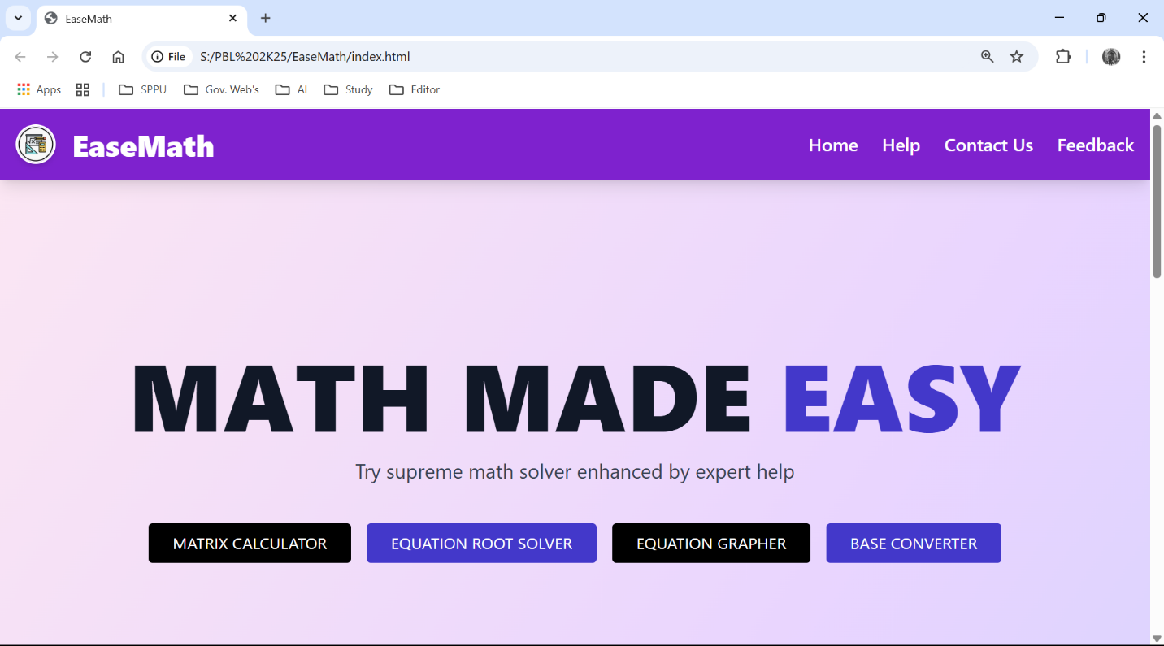

Matrix Calculator:
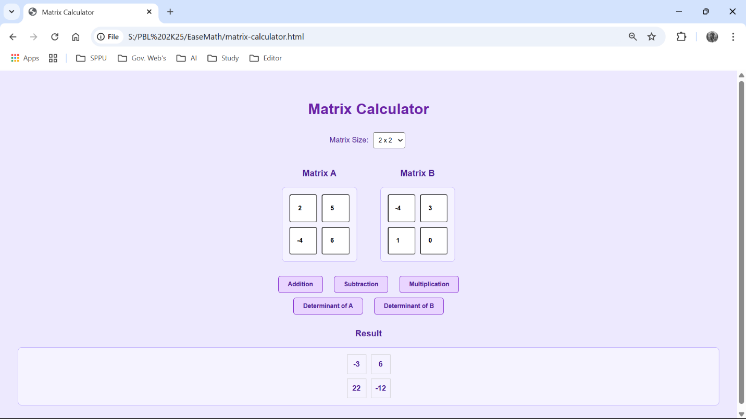

- Equation to Root Solver:
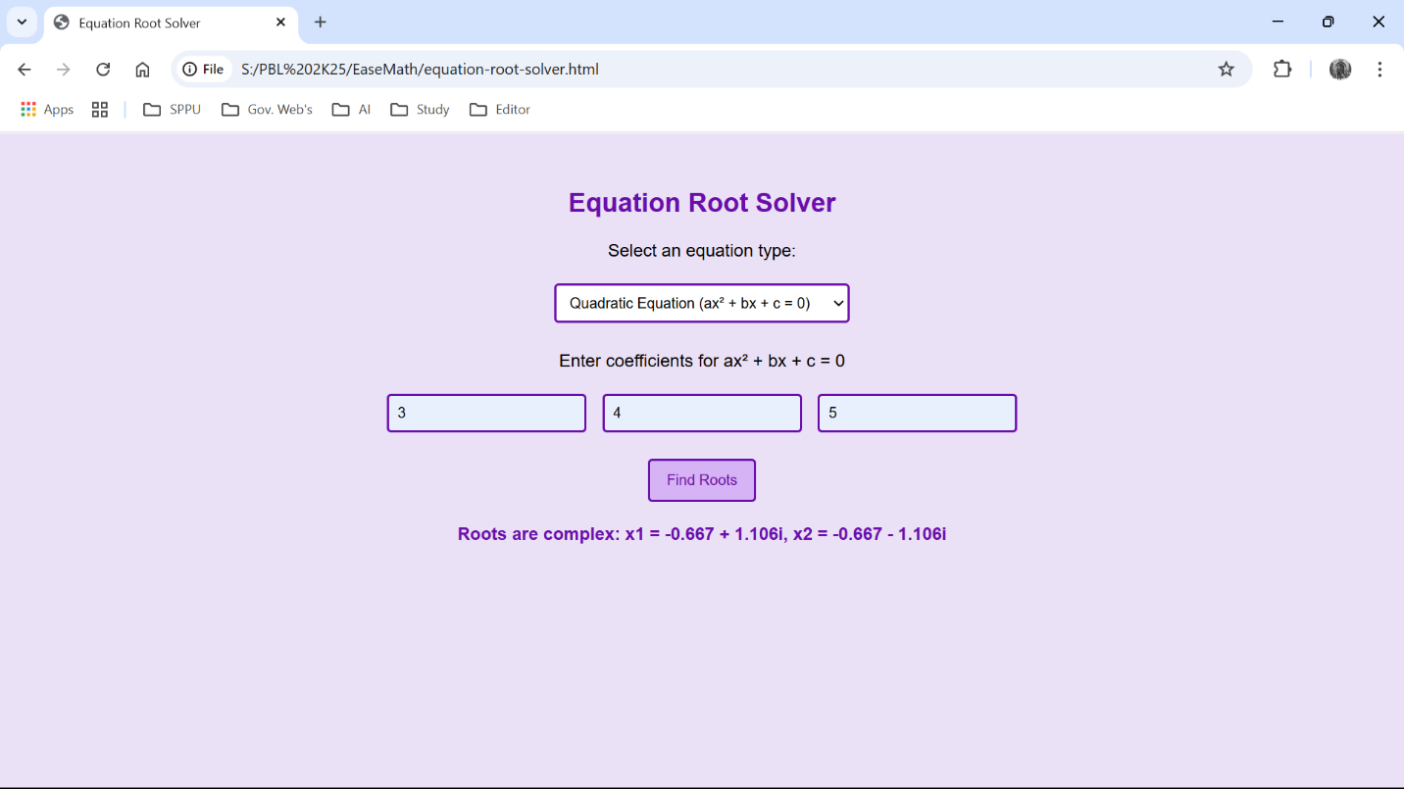

- Equation Grapher:
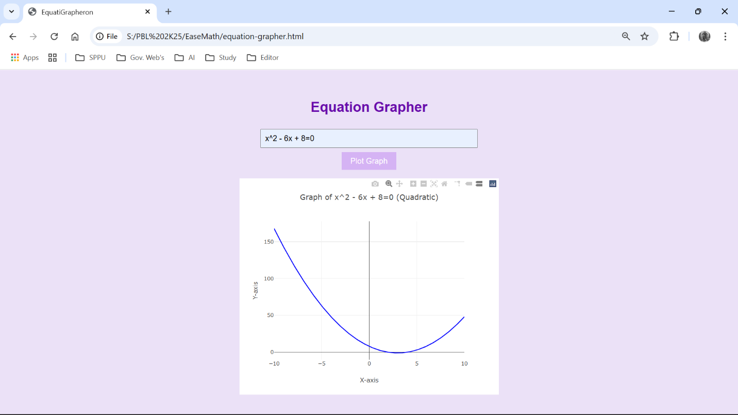

- Base Converter (Number System Converter):
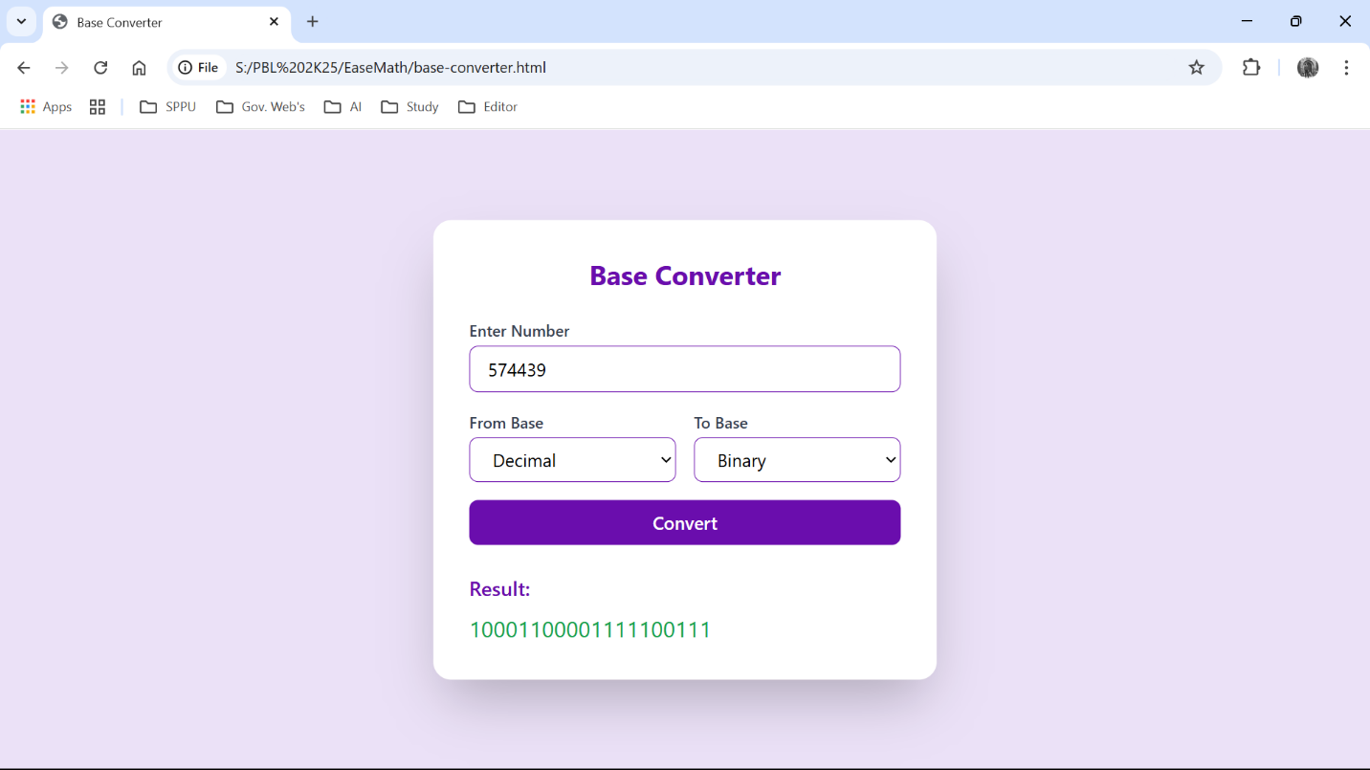

- Help Section:
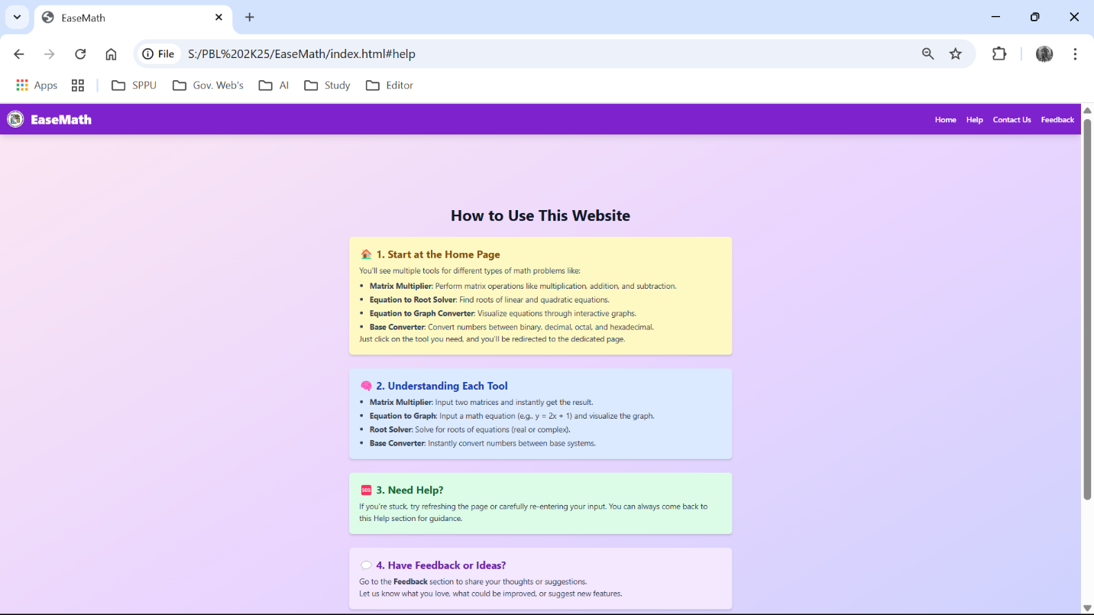

Contact Us Section:

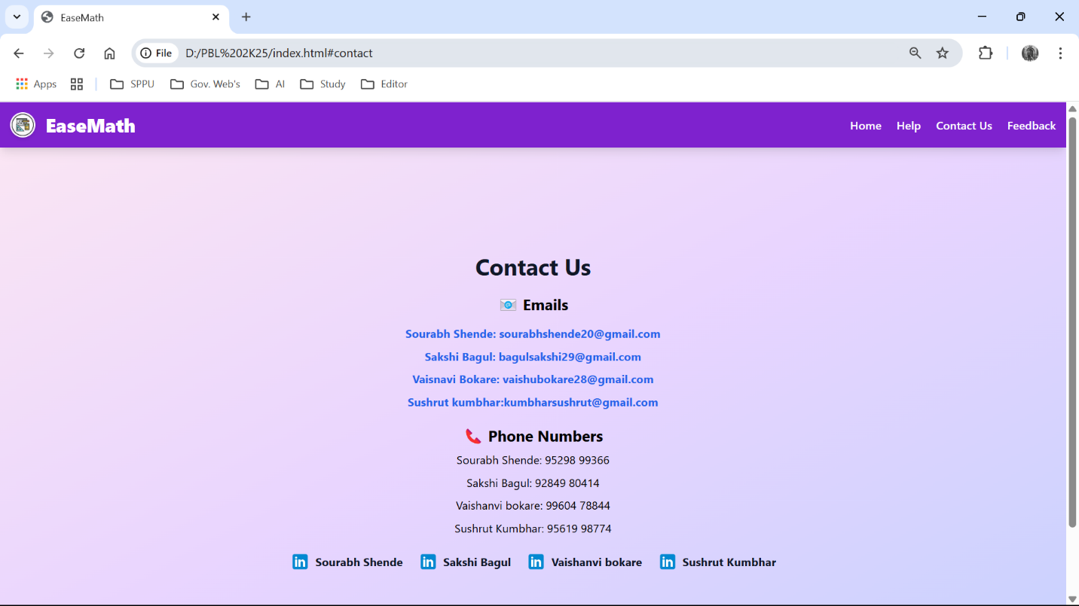

Feedback and Suggestions Section:

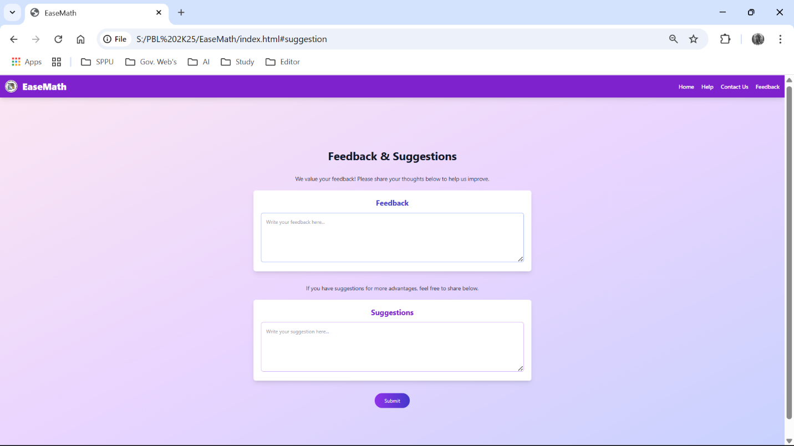

CONCLUSION

Efficient Mathematical Solutions: The project provides quick and reliable solutions for various math problems like matrix operations, root solving, and graph plotting using optimized algorithms.

User-Friendly Interface: A clean, responsive design ensures easy access and interaction across all devices, enhancing user experience.

Real-Time Computations: The system performs calculations efficiently in real-time with minimal delay, ensuring smooth user interaction.

Scalability and Security: The architecture supports scalability for future additions of tools and ensures robust security for safe user interactions.

